**Q. Write a Problem Analysis Chart (PAC), Algorithm and Flowchart for finding greatest number among three numbers.**

PAC

|  |  |  |  |
| --- | --- | --- | --- |
| **Data** | **Processing** | **Output** | **Solution Alternatives** |
| Number 1  Number 2  Number 3 | Compare Number 1, Number 2, Number 3 for the greatest | Print Number 1 or Number 2 or Number 3 is greatest |  |

Algorithm

* Start
* Use variable **Number1**, **Number2**, **Number3**
* Read **Number1**, **Number2**, **Number3**
* if **Number1** > **Number2**

if **Number1** > **Number3**

Print “**Number1** is the greatest”

else

Print “**Number3** is thegreatest”

else

if **Number2** > **Number3**

Print “**Number2** is the greatest”

else

Print “**Number3** is the greatest”

* Stop

Flowchart

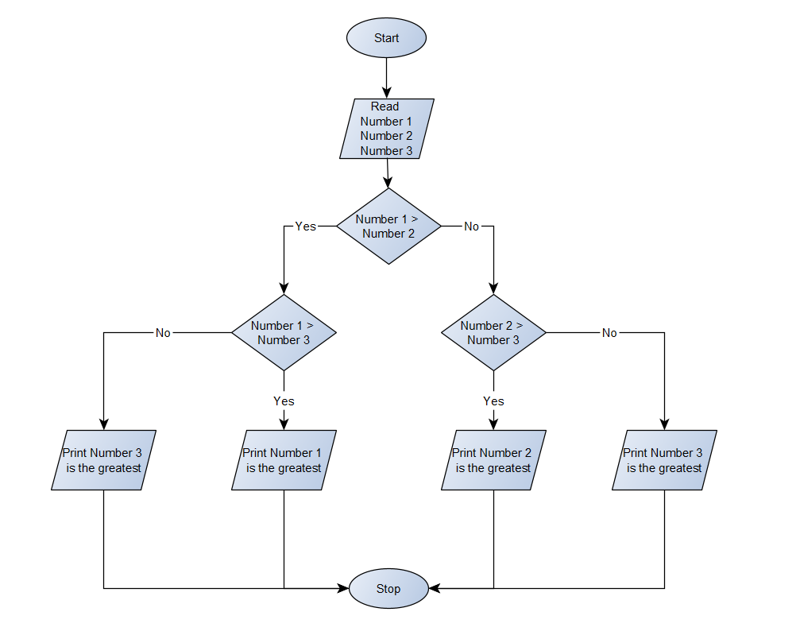

Python Program

print(**"Enter the three numbers that you want to compare :"**)  
Number1 = float(input(**"Number 1 : "**))  
Number2 = float(input(**"Number 2 : "**))  
Number3 = float(input(**"Number 3 : "**))  
if Number1 > Number2:  
 if Number1 > Number3:  
 print(Number1, **"is the greatest"**)  
 else:  
 print(Number3, **"is the greatest"**)  
else:  
 if Number2 > Number3:  
 print(Number2, **"is the greatest"**)  
 else:  
 print(Number3, **"is the greatest"**)